Adoption of improved GLDC crop varieties: A synthesis of evidence
Tesfaye Woldeyohanes, Judith Odoul, Kai Mausch, Karl Hughes

Acronyms
CG | Consultative Group
CGIAR | Consultative Group for International Agricultural Research
CIAT | International Center for Tropical Agriculture
CIMMYT | International Maize and Wheat Improvement Center
CRP | CGIAR Research Program
DC | Dryland Cereal
DIIVA | Diffusion and Impact of Improved Varieties in Africa
DR Congo | Democratic Republic of Congo
FPVS | Farmers Participatory Varietal Selection
GL | Grain Legumes
GLDC | Grain Legumes and Dryland Cereals
HOPE | Harnessing Opportunities for Productivity Enhancement
ICARDA | International Center for Agricultural Research in Dry Areas
ICRISAT | International Crops Research Institute for Semi-arid Tropics
IITA | International Institute of Tropical Agriculture
ISPC | Independent Science and Partnership Council
IV | Improved Variety
MEL | Monitoring, Evaluation and Learning
NARS | National Agricultural Research Systems
SA | South Asia
SLO | System Level Outcomes
SPIA | Standing Panel on Impact Assessment
SRF | Strategy and Result Frameworks
SSA | Sub-Saharan Africa
TL | Tropical Legume
TRIVSA | Tracking Improved Varieties in South Asia

Abstract
There have been several interventions by CGIAR research programs to provide improved technologies of grain legumes and dryland cereals of high productivity, profitability, resilience, and marketability. Understanding the extent of use of these technologies is a key step to estimate its impact on the welfare of smallholder households. The objective of this review was to map adoption evidence of improved Grain legume and Dryland Cereal (GLDC) crop varieties based on the latest adoption data available from sub-Saharan Africa and Asia countries. The mapping was done for 9 GLDC mandate crops and 13 target countries resulting in 35 country crop combinations. The synthesis result highlighted some of the following key findings. Adoption evidence is scarce as the number of surveys conducted over the last decade is quite limited. As a result, data is lacking for some crops in the target countries (e.g., Sorghum in Ethiopia and Groundnut in Tanzania) and are old for some crop and country combinations. Overall, an estimated 43% of GLDC crop area is grown to improved varieties, 20.5M hectares are under improved GLDC crop varieties and an estimated 21.9M smallholder farmers have adopted improved GLDC crops in the target countries. The estimated number of farm households that have adopted improved GLDC varieties exceeds the target households to be reached by 2022 by about 13M households. There are some methodological issues related to adoption measurement that impede an accurate estimation of adoption extent.

Table of Contents
1. Introduction 1
2. Data and Methods 2
2.1. Search methods and selection criteria 3
2.2. Inclusion and exclusion criteria 3
2.3. Quality assessment 3
3. Results and discussion 4
3.1. Description of the included adoption studies 4
3.2. Overview of varietal releases 9
3.3. Evidence of adoption by mandate crops and country 10
3.4. Evidence of adoption aggregated by target countries and crops 12
3.4.1. Area under improved varieties of GLDC crops 13
3.4.2. Number of farm households adopted improved GLDC varieties 15
3.4.3. Changes since 2010 16
4. Conclusions 16

Introduction
The CGIAR Research Program for Grain Legumes and Dryland Cereals (GLDC) supports prioritized integrated research on grain legumes and cereal crops grown in the semi-arid and sub-humid dryland agro-ecologies of sub-Saharan Africa (SSA) and South Asia (SA). These agro-ecologies are where the societal grand challenges, specifically targeted in the CGIAR Strategy and Result Frameworks (SRF) – poverty, malnutrition, climate change, and soil degradation are most acutely evident. The GLDC aims to contribute to addressing these challenges by increasing productivity, profitability, resilience, and marketability of critical and nutritious grain legumes and cereals within these agro-ecologies. The program has set aspirational targets to contribute positively to the CGIAR System Level Outcomes (SLO) of reducing rural poverty, increasing food security, improving nutrition and health, and managing natural resources more sustainably. Under SLO 1.1(reduce poverty), the GLDC targets to reach 8.9 and 21.7 farm households that have adopted improved GLDC verities in the target countries, by 2022 and 2030 respectively (CRP-GLDC, 2018).
The CGIAR has made significant investments in legume and cereal improvement research over the last four decades. The research investments involved multiple projects funded bilaterally, recently through GLDC and two CRPs – Grain Legume (GL) and Dryland Cereal (DC) and formerly through different international agricultural research centers such as the International Institute of Tropical Agriculture (IITA) for cowpea and soybean, the International Center for Tropical Agriculture (CIAT) for bean, the International Center for Agricultural Research in Dry Areas (ICARDA) for lentil and the International Crops Research Institute for the Semi-Arid Tropics (ICRISAT) for chickpea, groundnut and pigeonpea, millet and sorghum. These interventions supported the development and release of an increased number of new varieties of different grain legumes and dryland cereal crops in SSA and SA countries. The GLDC research emphasizes the right enabling environment to overcome the adoption and scaling barriers and create the incentives for adoption of improved technologies and management practices at scale to achieve sought-after impacts.
However, the impacts of GLDCs’ research for development (R4D) interventions to transform the agri-food system of key cereal and legume crops have not been well documented. The program management wants to be better informed to understand to what extent the program has met its targets. Impact evidence is also imperative for informed decision-making as policymakers and donors want to allocate resources to fruitful lines of research and to strengthen the role of agricultural research in fighting poverty, hunger, and malnutrition. Moreover, appraising impacts can also help to inform future research activity (Kelly et al. 2008). Mapping of available evidence and estimating the extent of adoption of improved GLDC crop varieties is a key step in the impact assessment process. There is a growing body of literature on the adoption of improved varieties of grain legumes and dryland cereals. A large body of household survey research have been conducted by international agricultural research centers to document the level of adoption, explore factors that constrain varietal adoption and impacts (Asfaw et al., 2012; Kassie et al., 2010; Mazid et al., 2009; Shiferaw et al., 2008; Simtowe et al., 2011, 2010; Simtowe & Mausch, 2019). In addition to this, the Standing Panel on Impact Assessment (SPIA) of CGIAR commissioned a range of studies to document evidence of adoption and impacts of improved varieties of grain legume and cereal crops (Pachico, 2014; Tripp, 2011; Walker & Alwang, 2015). The most recent being the Diffusion and Impact of Improved Varieties in Africa (DIIVA project) and Tracking Improved Varieties in South Asia (TRIVSA project), which have documented varietal adoption and diffusion for various crops in Sub-Saharan Africa and South Asia for the period between 1998 and 2010 (Walker & Alwang, 2015). Another study by Pachico (2014) reviewed and charted insightful synthesis on the adoption of improved varieties of legume crops using over 30 impact assessment and adoption studies conducted in more than 20 countries in Africa. This work is an updated review of recent evidence building on the previous works particularly taking the DIIVA and TRIVSA studies as a benchmark. This is important because adoption is a dynamic process that occurs over time following the diffusion process (Pachico, 2014). Growers of improved variety at one time may also abandon and switch back to the old variety or landrace due to various factors such as lack of access to input and output markets (Simtowe & Mausch, 2019). Therefore, up to date information on the level of varietal adoption is crucial for credible impact assessment. The available evidence is dispersed across countries and regions being documented by project implementing centers and national partner institutions. Systematic mapping of this evidence is crucial for a better understanding of the scale and depth of adoption to provide credible evidence on targets achieved at scale. This paper aims to contribute to filling this gap by synthesizing evidence on the adoption of improved varieties of GLDC crops in the target countries. In our review paper, we also identify the gaps by revealing where adoption evidence is missing, and future research is needed.
Our process of assessing the impact of research activity uses an indicator that measures progress towards achieving the GLDC target and this paper focuses on the adoption of improved varieties newly developed or promoted through GLDC projects in collaboration with countries' national agricultural research system (NARS). The extent of adoption is one of the indicators used by GLDC to measure progress towards achieving its target. In an adoption study, this is usually measured as the percentage of area grown to improved varieties and sometimes as a percentage of smallholder farmers growing improved varieties (CIMMYT Economics Program, 1993). Improved varieties include both selections from landraces and breeding lines as well. While we include adoption studies dating back to 2007 in our literature search, the focus here is on more recent adoption and impact studies. We have used the adoption evidence documented by DIIVA and TRIVSA project (Walker & Alwang, 2015) as a benchmark to see what has been changed and where the change has occurred. Although adoption is a dynamic process that occurs over time, we attempt to capture the latest snapshot based on current knowledge. Adoption evidence from Walker and Alwang (2015) is used to estimate the extent of adoption at the national level for cases where the latest adoption study is not available.
The remaining part of the paper is organized as follows. Section two presents data and methods followed by results and discussion before we conclude.

Data and Methods
A systematic review was used to assemble adoption and impact assessment studies of GLDC crops conducted from 2007 to 2020 in Sub-Saharan Africa (SSA) and South Asia (SA) regions focusing on GLDC target crops and countries. In our systematic review approach, we have followed key guidelines (i) an explicit search strategy involving online search to retrieve literature from scientific and organizational databases; (ii) clear inclusion/exclusion criteria; (iii) validation of the database with key scientists, and (IV) systematic coding and analysis of the included studies.

Search methods and selection criteria
Two types of data sources were utilized to compile adoption studies: (i) Online search involving searching for information from scientific literature databases and organizational archives and (ii) Through communication with key CG Centre scientists for documents that are unpublished or not accessible. An online search for peer-reviewed scientific publications and grey literature was performed using a string that combines adoption, GLDC priority countries, and crops as keywords covering literature published between 2007 and 2020. The search was conducted in the archives of the International Crops Research Institute for Semi-arid Tropics (ICRISAT), Google Scholar, and CGIAR Monitoring Evaluation and Learning (CGIAR-MEL) database. The archives of ICRISAT and CGIAR-MEL database were used to retrieve grey literature which includes research reports and working papers by CG Centres.

Inclusion and exclusion criteria
Clear criteria for evaluation of the quality of retrieved documents were developed a priori. Accordingly, a document was included in the study if it fulfilled the following a priori eligibility criteria.
- Study focuses on one or more of the GLDC priority crops – seven legumes (Chickpea, Common Bean, Cowpea, Groundnut, Lentil, Pigeonpea, and Soybeans) and two dryland cereals (Millet and Sorghum).
- Study focuses on one or more of the 13 priority countries across the SSA (Burkina Faso, Ethiopia, Malawi, Mali, Mozambique, Niger, Nigeria, Sudan, Tanzania, Uganda, and Zambia) and South Asia (India, Myanmar).
- Adoption of one or more of the improved GLDC crop varieties by farmers in the priority countries.
- Timeframe: 2007-2020 (Cover both phase 1 and 2 of the GLDC research program)
- Type of publication
  - Adoption and impact evaluation studies (journal articles, conference papers, working papers, and discussion papers) that use primary data
  - Project annual and final reports
  - Project evaluation reports
- A substantively similar version of the same study will not be included in the review (e.g. working paper versus published version).
- Language: English

Quality assessment
The retrieved adoption studies were screened for quality, content, and criteria as defined above. The quality of the retrieved documents was assessed based on sampling design, sample size, and clear description of interventions by CG Centers and partner institutions. Adoption studies based on non-random and small sample sizes were not included to ensure representativeness. Similarly, adoption studies were excluded if there was no evidence of certain interventions by CG Centers or partner institutions. Studies based on experimental or farmers participatory varietal selection (FPVS) trials were also excluded as trial phase evidence would be problematic for inference.
The retrieved studies retained after screening and eligibility assessment were coded into a spreadsheet to capture key information. This was then shared with key CGIAR scientists who are involved in GLDC research to validate the database and provide any documents on the latest adoption studies that are unpublished or difficult to access.

Results and discussion
In this section, we present and discuss the 68 adoption studies identified through the search and screening process. We briefly describe this process and the results at each stage. Then we discuss the characteristics and trends of the evidence base and discuss the gaps. This is followed by a brief discussion of recent varietal releases. Finally, detailed synthesis of the adoption evidence is presented crop by crop and the estimated adoption rate in terms of percentage of area grown to improved GLDC crops, area under improved variety and number of smallholder farmers adopted for each mandate crop and country.

Description of the included adoption studies
An overview of the review process showing the number of studies during the subsequent screening and selection procedures is presented in Figure 1. Our online search returned 203 studies and additional 17 studies were identified through other sources resulting in 220 studies. Out of these, 67 were removed as duplicates and the remaining 153 studies were screened on title and abstracts. The title and abstract screening removed additional 63 studies leaving 90 studies that were screened at full text. Out of these 90 studies, only 63 met the inclusion criteria. Including three additional adoption studies obtained directly from Scientists, a total of 68 studies were included in the systematic review. The 27 studies were excluded with reasons as explained in the previous section.
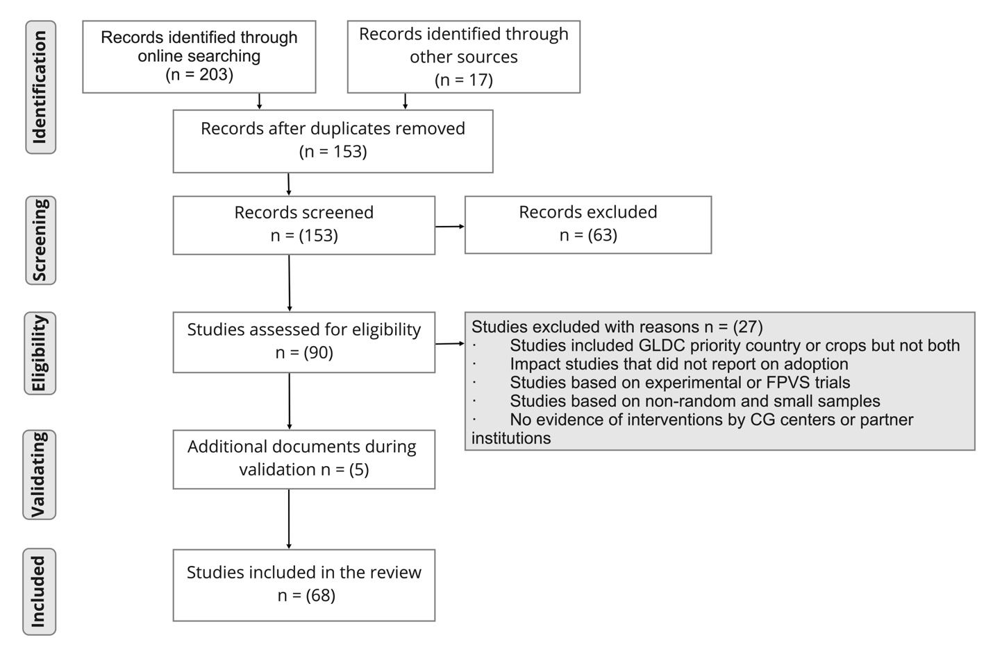
Figure 1: Flow diagram of the review of adoption studies of improved varieties of GLDC crops
Out of the 68 retained adoption and impact assessment studies, only 35 with the latest adoption data were used for the resulting synthesis. This is because for some of the crops there were two or more studies that have used data from different periods which can be used to track the adoption progress over the years. Similarly, some of the studies have used the same dataset to analyze different aspects of impact. However, for the synthesis of results, only the recent adoption data were used per crop and country combinations.
Figure 2: Type of scientific publications reviewed

As shown in the pie diagram in Figure 2, most of the adoption studies reviewed in this study were articles published in peer-reviewed journals followed by book chapters and research reports of different types.
Estimates of varietal adoption can be obtained by gathering data directly from farmers through a statistically representative survey or expert opinion survey. Even though it is expensive to collect data from a representative sample of farmers, it provides more accurate estimates of adoption compared to expert estimates (Pachico, 2014). More than three-quarters of the studies reviewed in this paper utilized survey data that are nationally representatives or representative of major growing areas for a specific crop. The remaining have used data gathered through an expert opinion by interviewing individual scientists and sometimes complemented with additional secondary data such as crop area from GPS tool.
Figure 3 presents the number of studies by the survey year. It shows studies that have used data collected in 2010 are dominant. Most of these studies are from the book entitled Crop improvement, adoption and impact of improved varieties in food crops in Sub-Saharan Africa, edited by Walker and Alwang (2015) that have used data from an expert panel collected in 2009/2010 as part of DIIVA and TRIVSA projects (Walker & Alwang, 2015). As mentioned above, we have used DIIVA and TRIVSA studies to document varietal adoption for crop and country combinations where the latest data were not available.
Figure 3: Number of studies per survey year
Our result shows that recent survey evidence is scarce as the number of adoption surveys conducted over the last decade for some crops and some countries is quite limited. As shown in Table 1, out of the 35 adoption survey evidence used in the resulting synthesis of this study, only 16 surveys by crop country combinations were collected after 2010. The remaining 19 were collected in 2010 or earlier and most of them were from the DIIVA and TRIVSA project. This limits our ability to track real changes in terms of varietal adoption using previous studies as a benchmark.
Table 1: Adoption survey evidence collected before and after 2010, by crop and country
Crop | Country
Adoption survey conducted in 2010 and before
Cowpea | Burkina Faso (2009), Mali (2009), Mozambique (2009)
Groundnut | India (2010), Malawi (2009), Mali (2010), Uganda (2010)
Millet | Burkina Faso (2010), Mali (2010), Niger (2010), Nigeria (2010)
Pigeonpea | India (2010), Malawi (2010)
Sorghum | Burkina Faso (2010), Ethiopia (2002-2003), Nigeria (2010), Sudan (2009)
Soybean | Nigeria (2009), Zambia (2010)
Adoption survey conducted after 2010
Chickpea | Ethiopia (2014), India (2012), Myanmar (2018)
Common Bean | Ethiopia (2016), Malawi (2013), Tanzania (2016), Uganda (2011)
Cowpea | Nigeria (2017)
Groundnut | Nigeria (2012), Tanzania (2016)
Lentil | India (2017)
Millet | Maharashtra, India (2013)
Pigeonpea | Tanzania (2016)
Sorghum | Maharashtra, India (2013), Mali (2015)
Soybean | Malawi (2017)
Note: The value in the parenthesis shows the year data was collected
Most of the adoption and impact studies are concentrated in Ethiopia, Tanzania and Nigeria for the SSA region followed by India for the SA region (Fig. 4). This is partly due to the fact that the number of crops represented per country higher for these countries, for instance 5 and 6 crops for Nigeria and India, respectively shown in Figure 6. At the same time, these crops were the most widely covered in the adoption and impact studies reviewed in this paper as shown in Figure 5.
Figure 4: Number of studies per GLDC priority country

Figure 5: Studies by GLDC priority crops

Overview of varietal releases
Recent reviews by Varshney et al. (2019) and Walker and Alwang (2015) show that CGIAR legume research has produced a significant number of varietal outputs both in Sub-Saharan Africa and South Asian countries. Table 1 summarizes new varietal releases for different legume crops in Sub-Saharan Africa countries over one decade between 2007 and 2017. The result shows that a total of 322 grain legume varieties were released during this period in SSA countries. Out of these about 183 were new common bean varieties. Ethiopia is a leading country in common bean releases followed by Rwanda, DR Congo and Tanzania. There have been also a high number of varietal outputs for groundnut, cowpea and chickpea where a total of 60, 29, and 25 new varieties were released, respectively during the same period. The new varieties of groundnut have been released in Eastern and Southern and Western and Central African countries while cowpea is mainly in West and Central Africa. The major success in new varietal release for chickpea was achieved in three East African countries – Ethiopia, Kenya and Tanzania. Overall, the trend of varietal release for most of the legume crops has increased in recent years compared the to early 2000s.
The achievement of the varietal development and releases are mostly related to research activities conducted under the three phases of the Tropical Legume project (TL) in African countries (Monyo & Varshney, 2016). Information from project reports indicates that about 304 improved varieties of legume crops developed in 15 countries in Africa, India and Bangladesh. India is leading in varietal release from South Asian countries where a considerable number of new varieties of legume crops were released. According to Varshney et al.(2019), about 16 groundnut,7 pigeonpea and 3 chickpea varieties were newly released in India.
Unlike legume crops, a comprehensive review of recent varietal release for the dryland cereals is scarce. A report by ICRISAT led project called Harnessing Opportunities for Productivity Enhancement (HOPE) indicates about 49 cultivars of dryland cereals (25 Sorghum, 13 Pearl Millet and 11 Finger Millet) were released between 2009 and 2016

Table 2: Grain legumes research output in SSA – varietal releases (2007-2017)
Country | Chickpea | Common Bean | Cowpea | Groundnut | Lentil | Pigeonpea | Soybean | All legume crops
Burundi |  | 18 |  |  |  |  |  | 18
Burkina Faso |  |  | 6 |  |  |  |  | 6
DR Congo |  | 22 |  |  |  |  |  | 22
Ethiopia | 11 | 28 |  |  | 1 |  |  | 40
Ghana |  |  | 4 |  |  |  |  | 4
Kenya | 9 | 17 |  |  |  | 3 | 7 | 36
Malawi |  | 13 |  | 7 |  | 3 |  | 23
Mali |  |  | 7 | 9 |  |  |  | 16
Mozambique |  | 8 |  | 6 |  | 4 |  | 18
Niger |  |  | 5 | 5 |  |  |  | 10
Nigeria |  |  | 7 | 3 |  |  |  | 11
Senegal |  |  |  | 6 |  |  |  | 6
Sudan | 1 |  |  |  |  |  |  | 1
Rwanda |  | 25 |  |  |  |  |  | 25
Uganda |  | 18 |  | 12 |  |  |  | 30
Tanzania | 4 | 21 |  | 12 |  | 2 | 2 | 41
Zambia |  |  |  |  |  |  |  | 8
Zimbabwe |  | 6 |  |  |  | 2 |  | 7
All SSA | 25 | 183 | 29 | 60 | 1 | 14 | 10 | 322

Source: compiled from Varsheny et al.(2019) and Walker and Alwang (2015)

Evidence of adoption by mandate crops and country
In this section we will present and discuss evidence adoption of improved varieties by mandate crops. This is important as it lies the foundation for impact assessment and generates parameters required for this activity for each of the GLDC crops in the intervention regions. The following discussion is organized by legume and cereal crop species relying mainly on the synthesis of the most recent adoption and impact studies.

    - Grain legumes
Chickpea
Chickpea is the second-largest grown and produced legume crop of the world after dry beans (Monyo & Varshney, 2016). Over 80% of the chickpea production comes from SA. India is the largest producing country in the world accounting for about 70% of global chickpea production. In Sub-Saharan Africa, chickpea is produced in Ethiopia, Tanzania, Malawi and Kenya.
The GLDC research for development interventions for chickpea targeted three countries in Sub-Saharan country and South Asia– Ethiopia, India and Myanmar. In Ethiopia, the International Crops Research Institute for the Semi-Arid Tropics (ICRISAT) through the Tropical Legumes projects (TL II Phase I and Phase II, TL III) worked closely with partners including the NARS, the International Centre for Agricultural Research in Dry Areas (ICARDA), and several implementing organizations contributing to the release of 11 improved varieties targeting various agro-ecologies of Ethiopia. The project activities also include farmers’ knowledge empowerment and capacity building, improving the availability and delivery of seeds to enhance the adoption of these improved varieties. As a result, adoption of the improved chickpea varieties rose from 31 to 80% between 2007 and 2014 evidenced by the household survey from three districts in Oromia and Amhara region (Verkaart et al., 2019).

Common Bean

Cowpea

Groundnut

Lentil

Pigeonpea

Soybean

    - Dryland cereals
Pearl Millet
Sorghum
Figure 6: National adoption rate (% area) by country and crop combination

Table 3: Average adoption rate of GLDC crops aggregated by target countries
Crop | Target countries | Average adoption rate  (% area)
Grain legumes
Chickpea | Ethiopia, India, Myanmar | 58
Common Bean | Ethiopia, Malawi, Tanzania, Uganda | 32
Cowpea | Burkina Faso, Nigeria, Mozambique, Mali | 24
Groundnut | India, Malawi, Mali, Nigeria, Tanzania, Uganda | 43
Lentil | India | 40
Pigeonpea | India, Malawi, Tanzania | 56
Soybean | Malawi, Nigeria, Zambia | 74
Dryland cereals
Millet | Burkina Faso, India, Mali, Niger, Nigeria | 27
Sorghum | Burkina Faso, Ethiopia, India, Mali, Niger, Sudan | 33
Total |  | 43

Evidence of adoption aggregated by target countries and crops

Area under improved varieties of GLDC crops

Table 4: Area under improved varieties of GLDC crop by region and target country
Region/country | Total crop area(ha) | Area under improved variety (ha)
South Asia | 17,571,580 | 11,389,172
India | 17,203,190 | 11,043,651
Myanmar | 368,390 | 345,520
Sub-Saharan Africa | 38,179,641 | 9,196,654
Burkina Faso | 2,685,200 | 152,440
Ethiopia | 529,957 | 213,236
Malawi | 953,255 | 442,670
Mali | 3,575,963 | 1,032,253
Mozambique | 352,000 | 38,720
Niger | 6,500,000 | 747,500
Nigeria | 14,426,705 | 3,339,279
Sudan | 6,652,500 | 2,687,610
Tanzania | 1,411,172 | 234,166
Uganda | 1,047,889 | 263,780
Zambia | 45,000 | 45,000
Total | 55,751,221 | 20,585,825

Table 5: Area under improved varieties of GLDC crop by target crops
Crop | Total crop area(ha) | Area under modern variety (ha)
Dryland cereals | 32,207,457 | 10,332,066
Millet | 12,829,690 | 2,478,122
Sorghum | 19,377,767 | 7,853,944
Grain legumes | 23,543,764 | 10,253,759
Chickpea | 1,232,145 | 807,223
Common Bean | 2,405,129 | 480,634
Cowpea | 4,354,770 | 884,557
Groundnut | 9,133,277 | 4,153,620
Lentil | 1,658,000 | 663,200
Pigeonpea | 3,913,729 | 2,579,715
Soybean | 846,714 | 684,810
Total | 55,751,221 | 20,585,825

Number of farm households adopted improved GLDC varieties

Table 6: Estimated number of smallholder farmers adopted improved varieties of GLDC crops by region and country
Row Labels | Estimated number of households adopted
South Asia | 5,427,510
India | 5,270,456
Myanmar | 157,055
Sub-Saharan Africa | 16,483,348
Burkina Faso | 102,463
Ethiopia | 278,530
Malawi | 8,010,815
Mali | 417,266
Mozambique | 193,600
Niger | n.a
Nigeria | 6,952,447
Sudan | n.a
Tanzania | 127,921
Uganda | 416,177
Zambia | n.a
Total | 21,926,729

Table 7: Estimated number of households adopted improved varieties of GLDC crops by target crops
Row Labels | Estimated number of households adopted
Dryland cereals | 11,441,842
Millet | 2,422,448
Sorghum | 9,019,394
Grain legumes | 10,469,016
Chickpea | 298,631
Common Bean | 823,125
Cowpea | 975,845
Groundnut | 8,109,724
Lentil | n.a
Pigeonpea | 101,283
Soybean | 160,407
Total | 21,910,858

Changes since 2010
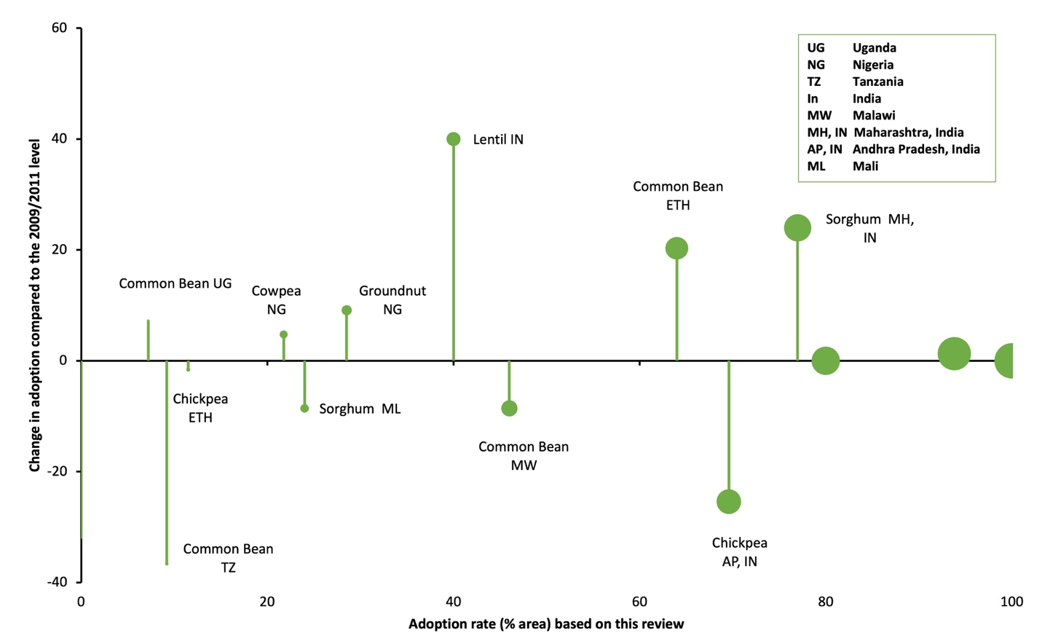

Conclusions
References
Asfaw, S., Kassie, M., Simtowe, F., & Lipper, L. (2012). Poverty Reduction Effects of Agricultural Technology Adoption: A Micro-evidence from Rural Tanzania. Journal of Development Studies, 48(9), 1288–1305. https://doi.org/10.1080/00220388.2012.671475
CIMMYT Economics Program. (1993). The Adoption of Agricultural Technology: A Guide for Survey Design. International Maize and Wheat Improvement Center.
CRP-GLDC. (2018). CGIAR Research Programme, Grain Legumes and Dryland Cereals Agri-Food Systems, Proposal. http://link.springer.com/10.1007/BF02772888
Kassie, M., Shiferaw, B., & Muricho, G. (2010). Adoption and impact of improved groundnut varieties on rural poverty: Evidence from rural Uganda. Environment for Development Discussion Paper - Resources for the Future (RFF), No.10-11. https://www.cabdirect.org/cabdirect/abstract/20103194803
Mazid, A., Amegbeto, K., Shideed, K., & Malhotra, R. (2009). Impact of Crop Improvement and Management: Winter-Sown Chickpea in Syria. 53.
Monyo, E., & Varshney, R. K. (Eds.). (2016). Seven seasons of learning and engaging smallholder farmers in the drought-prone areas of sub-Saharan Africa and South Asia through Tropical Legumes, 2007–2014.
Pachico, D. (2014). Towards appraising the impact of legume research: A synthesis of evidence (p. 39). Standing Panel on Impact Assessment (SPIA), CGIAR INdependent Science and Partnership Council (ISPC).
Shiferaw, B. A., Kebede, T. A., & You, L. (2008). Technology adoption under seed access constraints and the economic impacts of improved pigeonpea varieties in Tanzania. Agricultural Economics, 39, 1–15.
Simtowe, F., Asfaw, S., Diagne, A., & Shiferaw, B. A. (2010). Determinants of Agricultural Technology adoption: The case of improved groundnut varieties in Malawi. 48th Agricultural Economists Association of South Africa, 31pp. http://oar.icrisat.org/5060/
Simtowe, F., Kassie, M., Diagne, A., Silim, S., Muange, E., Asfaw, S., & Shiferaw, B. (2011). Determinants of Agricultural Technology adoption: The Case of Improved Pigeonpea Varieties in Tanzania. Quarterly Journal of International Agriculture, 50(4), 325–345.
Simtowe, F., & Mausch, K. (2019). Who is quitting? An analysis of the dis-adoption of climate smart sorghum varieties in Tanzania. International Journal of Climate Change Strategies and Management (TSI), 11(3), 341–357.
Tripp, R. (2011). The Impacts of Food Legume Research in the CGIAR: A Scoping Study. 44.
Varshney, R. K., Ojiewo, C. O., & Monyo, E. (2019). A decade of Tropical Legumes projects: Development and adoption of improved varieties, creation of market-demand to benefit smallholder farmers and empowerment of national programmes in sub-Saharan Africa and South Asia. Plant Breeding (TSI), 138(4), 379–388.
Verkaart, S., Mausch, K., Claessens, L., & Giller, K. E. (2019). A recipe for success? Learning from the rapid adoption of improved chickpea varieties in Ethiopia. International Journal of Agricultural Sustainability (TSI), 17(1), 34–48.
Walker, T. S., & Alwang, J. (Eds.). (2015). Crop improvement, adoption, and impact of improved varieties in food crops in sub-Saharan Africa. CABI. https://doi.org/10.1079/9781780644011.0000

Survey year refers to data collection period for both household survey and expert interview
https://tropicallegumeshub.com/rc/304-improved-varieties-developed-in-15-countries-in-africa-india-and-bangladesh/
http://exploreit.icrisat.org/profile/Sorghum/193

