**FISH CRP**

**Cluster 2.2 Fish in Multifunctional Landscapes**

**Draft 2021 POWB**

Research under this cluster seeks to provide an evidence base to shift policies towards improved water, land and fisheries management and governance practices that lead to improved management, increased food and nutrition security and enhanced livelihood options at scale. By leveraging bilateral investments alongside WI/W2 funds, activities link grounded experimental work to improved management practices and models for scaling (e.g. integrated aquatic foods and agriculture production systems) with social research on gender and youth. Landscape scale innovations in improved water management specifically integrating fish into water control infrastructure together with bilateral investments in climate risk assessment modelling, scenario development and decision support tools tailoring and targeting investments in integrated aquatic food production systems are key priorities for 2021.

The cluster is delivered through three interlinked activity areas:

1.Test & refine ecosystem based water management & integrated production models

2.Trade-offs between sustainability, resilience, food security and wellbeing assessed

3.Cross-scale governance mechanisms tested & refined to account for external drivers

The research will contribute to the 2021 Milestones – ‘Wider application of improved management models’, and ‘nutrition-sensitive approaches to fisheries articulated’, and in addition contributes to 4 Sub-intermediate development outcomes –

* Increased livelihood opportunities
* Increased availability & access to nutrient-rich foods
* More productive & equitable management of natural resources
* Conducive agricultural policy environment

And will be expected at the system level to deliver outcomes – ensuring ecosystems are more sustainably and equitably managed, and consumption of more nutritious diverse diets by people especially the marginalised and women of reproductive age.

**---------------------**

**Product line/Activity 2.1**

Test & refine ecosystem based water management & integrated production models for enabling SSF in multi-use landscapes

***Priority action***

*Promoting and operationalizing the Guidelines ‘Increasing the benefits and sustainability of water control infrastructure through integration of fisheries: a guide for water planners, managers and engineers’:*

**Research Activities/Outputs**

* A targeted awareness campaign designed with comms outreach. More specifically, the target audience are irrigation practitioners and those making decisions on irrigation investments, including those within national departments of irrigation (e.g. MOALI in Myanmar and MOWRAM/CAVAC in Cambodia) and donor/agencies (e.g. ADB). The ultimate aim is that future investments in irrigation (and other WCI) are more fish friendly; negative impacts on fish are mitigated and there is greater enhanced recognition of the benefits that improved fisheries as aquaculture can bring to irrigation systems.
* A paper based on a desk review incorporating existing innovations (e.g., fish passes, rice-fish systems) in Myanmar/ Cambodia/ (also Laos) to take stock of the benefits of better integration and demonstrate appropriate governance mechanism

**Impact end of 2021**

* Ensure water sector and financial institutions strategies e.g., ADB incorporate fish friendly options in irrigation investment plans for the sector

**Product line Activity 2.2**

2.Trade-offs between sustainability, resilience, food security and wellbeing assessed

***Priority action***

*Geospatial tools for integrated, climate resilient food production.*

**Research Activities/Outputs**

A decision support tool for planners and managers

* Incorporating A database utilising research data from experimental trials and a broad range of biophysical and social data layers - including vulnerability and risk to climate and related drivers.
* The models and maps generated from the system are used to identify and target areas most suitable for integrated rice fish production systems.
* Business case and investment strategy for scaling developed with government partners in the Ayeyarwady Delta, Myanmar.
* A report and journal article on development of DSS

**Impact end of 2021**

* An enabling environment for adoption at scale and evidence of new investment in integrated rice and fish production systems

**Product Line Activity 2.3.**

3.Cross-scale governance mechanisms tested & refined to account for external drivers

***Priority action***

*Establish, refine and evaluate platforms for dialogue among land use, fisheries and agriculture policy makers and policy implementers for promotion and uptake of rice fish agri-food system interventions (RFS) employing integrated inter-sectoral GIS based spatial planning.*

**Research Activities/Outputs**

Scenario discussions and policy dialogues using evidence based economic and food/nutrition benefit valuation from the decision support tools developed in activity 2 used in integrated participatory planning processes at different scales to ensure the needs and aspirations of end users are included and deliberated over in informing decisions on investments most suited to the social, economic and environmental context.

**Impact end of 2021**

Integration of rice-fish considerations into broader land-water planning processes in the Ayeyarwady delta minimize the potential adverse impacts of related sector developments and enhance Land-water productivity where rice-fish approaches are adopted and scaled.

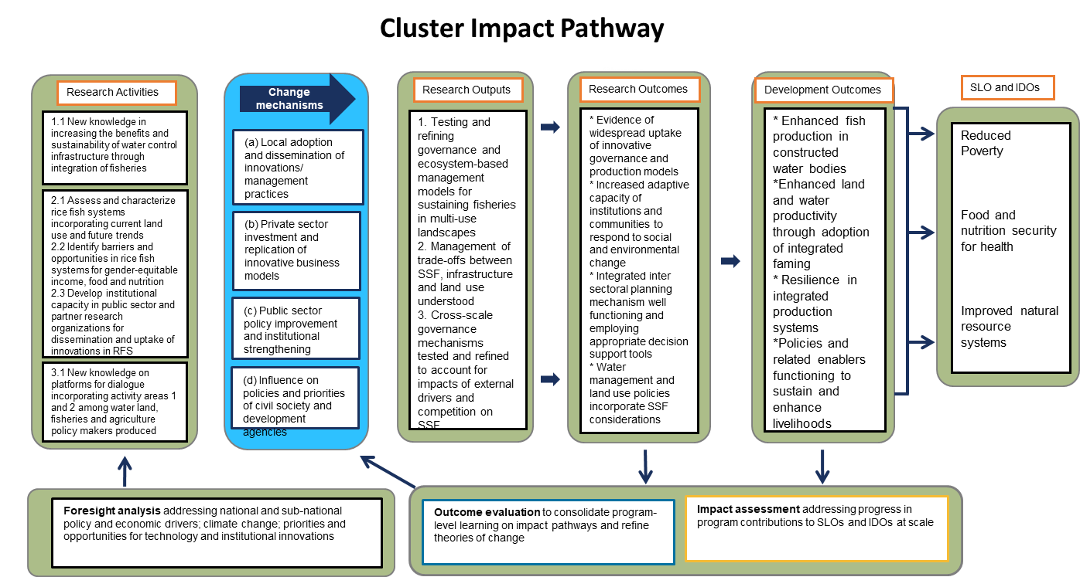

.

|  |  |  |  |  |
| --- | --- | --- | --- | --- |
| **Deliverables** | **Responsible lead** | **Other team members** | **Timeframe** | **Source (W1/W2 or co-funded bilateral/W3)** |
| Cluster co-leadership | Sonali Senaratna Sellamuttu (FTE 26 days) |  | Q1- Q4 | FISH W1/W2 |
|  | Mark Dubois  FTE 26 |  | Q1 – Q4 | FISH W1/W2 |
| **Product Line/Activity 2.1 Test and refine ecosystem-based water management and integrated production models for enabling SSF in multi-use landscapes**  *[Lead/ focal point for community of practice: Matthew McCartney]* | | | | |
| A targeted awareness raising campaign implemented at different scales – international, regional and national (Southeast Asia focus) to promote the Guidelines and joint paper with WF and CSU 2020) widely amongst water resource planners, managers and engineers  . | Matthew McCartney (FTE 7 days) | Toby Johnson (covered by IWMI comms), Sonali Senaratna Sellamuttu (FTE 4 days), Sanjiv de Silva (FTE 4 days)  Sarah F 5  Mark D 3  Mike A 1 |  | FISH W1/W2 and also , leveraging FAO networks, CSU partnership  WLE co-funding (TBC) |
| **Activity 2.2 Management of tradeoffs between SSF, infrastructure and land use understood**  *[Leads/focal points for community of practice: Mark Dubois]* | | | | |
| Model, database and report and/or journal article on decision support tool for Myanmar agriculture/water development | Mark Dubois  FTE 10 D | Shwu Jiao Teoh 24D  Mike A 1D  Hsu Mon Aung 24D  Sanjiv de Silva (FTE 7 days), Moet Palal (FTE 5 days) |  |  |
|  |  |  |  |  |
| Activities and investment plans for RFS to ensure scaling and uptake in next 5 years - include some projected benefit analysis and contributions to One CGIAR activities. | Mark Dubois  FTE 10 D | Matthew McCartney (FTE 8 days), Sonali Senaratna Sellamuttu (FTE 2 days), Sanjiv de Silva (FTE 2 days)  Sarah F 13D  Shwu Jiao Teoh  Mike A 3D |  | FISH W1/W2 |
| Journal article on 'applying and adjusting EAT Lancet recommendations' to multifunctional landscapes - (agri-aqua food systems) | Matthew McCartney (FTE 5 days) | Sashwat Dhungan,  Nishadi Eriyagama,  Luna Bharati (FTE covered through WLE)  Mark D 4D  Mike A 2D  Shakuntala T 3D |  | Collaboration with WLE/FISH.  IWMI co-authors to be covered by WLE project on *Transformation of rural landscapes for sustainable and nutritious food systems in Myanmar*. Some time for WorldFish colleagues will also be covered through the WLE project as this jointly supports (IWMI, WF and IRRI). |
| **Activity 2.3. Cross-scale governance mechanisms tested and refined to account for impacts of external drivers and competition on SSF**  *[Lead/focal points for community of practice: Sanjiv de Silva]* | | | | |
| Two cross-sector policy/planning dialogs to develop a strategy for scaling RFS in the Ayeyarwady Delta using the DSS innovation (refined GIS RFS suitability maps) developed under Cluster 2.[1] | Sanjiv de Silva (FTE 10 days) | Sonali Senaratna Sellamuttu (FTE 2 days), Moet, Palal (FTE 15 days), U Phayko (FTE 10 days),  Mark D 6D  Shwu Jiao T 10D  Mike A 2D | Both dialogs to be held in Q2 with DoF, DoA, Irrigation Department and the Department of Land management and Statistics (DALMS). One will be at national scale and the other at the Ayeyarwady Region scale to ensure decisions at the national scale are translated within local contexts. | FISH W1/W2 |
| Report evaluating how the DSS has influenced i) integrated land and water use decision making and ii) inter-agency coordination for RFS scaling, leading to integrated policy implementation (ADS[2], MS-NPAN[3], MSDP[4]).[5] | Sanjiv de Silva (FTE 10 days) | Sonali Senaratna Sellamuttu (FTE 1 day)  Mark D 4D  Shwu Jiao T 2D  Mike A 2D | A draft for review by end of Q3 2021 | FISH W1/W2  Leveraging the USAID Fish for Livelihoods project in Myanmar |

**Youth cross-cutting theme**

**Draft 2021 POWB**

|  |  |  |  |  |
| --- | --- | --- | --- | --- |
| **Deliverables** | **Responsible Lead** | **Other IWMI team members** | **Timeframe** | **Source (W1/W2 or co-funded bilateral/W3)** |
| Report on youth cross-cutting theme for the FISH Annual Report and to the FISH MC | Sonali Senaratna Sellamuttu (FTE-2 days) | - | FISH Annual Report (March 2021) | FISH W1/W2 youth budget) |
| Contributions on youth in fish food systems (including from the Myanmar youth case study) to the High-Level Panel of Experts on Food Security and Nutrition (HLPE) report on “Promoting youth engagement and employment in agriculture and food systems”. | Indika Arulingam (FTE 25 days) | Sonali Senaratna Sellamuttu (FTE-2 days), Sanjiv de Silva (FTE – 2 days) | July 2021 | FISH W1/W2 youth budget |
| Informed awareness campaign to bring together policymakers, development practitioners and research organizations to deliberate on the potential for an integrated food systems development approach to creating decent and viable livelihoods for young people in Myanmar[6]. This will include holding a webinar[7] and developing a policy brief that is based on the paper. | Indika Arulingam (FTE -15) | Sonali Senaratna Sellamuttu (FTE-2 days), Sanjiv de Silva (FTE – 4 days) |  |  |
| Joint comms piece with FISH/WLE on youth engagement within fish agri-food systems | Indika Arulingam (FTE 5 days) | Sonali Senaratna Sellamuttu (FTE-2 days), Likimyelesh Nigussie (FTE – 2 days), Sanjiv de Silva (FTE – 2 days) | Q3 2021 | FISH W1/W2 youth budget  and  WLE W1/W2 to cover WLE colleagues (Deepa Joshi) |
| Dissemination of findings of the Paper on livelihood aspirations of young women and men in Nigeria with a specific focus on aquaculture (linked to the TAAT and BMGF projects) – through a policy brief that is based on the paper. | Likimyelesh Nigussie (FTE – 10 days ) | Sonali Senaratna Sellamuttu (FTE-2 days) |  |  |

1. The DSS will help identify suitable areas for RFS scaling. The dialogs are needed to a) ensure the DSS recommendations are acceptable and b) to develop consensus on how actual scaling will be organized. The later will include addressing existing rules around land use; agreeing on inter-sectoral coordination arrangements and the financing of scaling. These actions around consensus building and coordination together with the DSS will also position RFS to be better integrated into the Asia Mega Deltas 2 degree initiative, particularly the emerging Ayeyarwady delta R4D program thus building One CGIAR activities. It will have similar benefits for the USAID Fish for Livelihoods project in which scaling rice-fish systems in 5 regions outside of the Delta is central.
2. Agriculture Development Strategy 2018/19 – 2022/3
3. Multi-sectoral National Plan of Action on Nutrition 2018 - 2022
4. Myanmar Sustainable Development Plan 2018 - 2030
5. Taking stock of the various strands of this work, the core for the report is the impact information can have on existing discourses policies, land-water use and institutional collaboration. This links to the key gap/challenge IWMI/WF have identified in pushing through policy, namely a lack of information for better articulating cross-sector challenges and visualizing solutions, reflecting also what DoF and DoA stated during the 1st dialog in Feb 2020.
6. Myanmar is currently experiencing growing rates of out-migration from rural areas, particularly from poorer households with most migrants being youth. At the same time, State investments continue to be heavily focused on the paddy sector, where mechanization has begun to displace labour requirements in many parts of Myanmar. This is despite the significant contributions made by other food systems such as inland fisheries, to nutrition and potentially to livelihoods.
7. Target audience for webinar - MOALI (as they are in charge of fisheries and agriculture), Ministry of Social Welfare, Relief and Resettlement (as they led the work on the youth policy), Ministry of Labour, Immigration and Population, ILO, Myanmar, IOM, Myanmar, FAO, Myanmar, LIFT Consortium (as they funded the CHIME study-which we looked at youth and migration), NAG,  
   WorldFish, Myanmar, IRRI, Myanmar and other stakeholders from the 2DI.